Dreamweaver E-Project

Topic

Metric Conversion Calculator



**Group Members**

* Idrees Gohar
* Touseef Ahmed
* Zahid Azeem

**Submitted To**

[eprojects@aptech.ac.in](mailto:eprojects@aptech.ac.in)

**Project Instructor**

Miss Binish Riaz

**Curriculum Code**

**6740**



The main purpose of this website is to perform metric conversions easily. The website also provides the basic understanding of metric conversions, their formulas, charts and some articles on Metric Conversions.

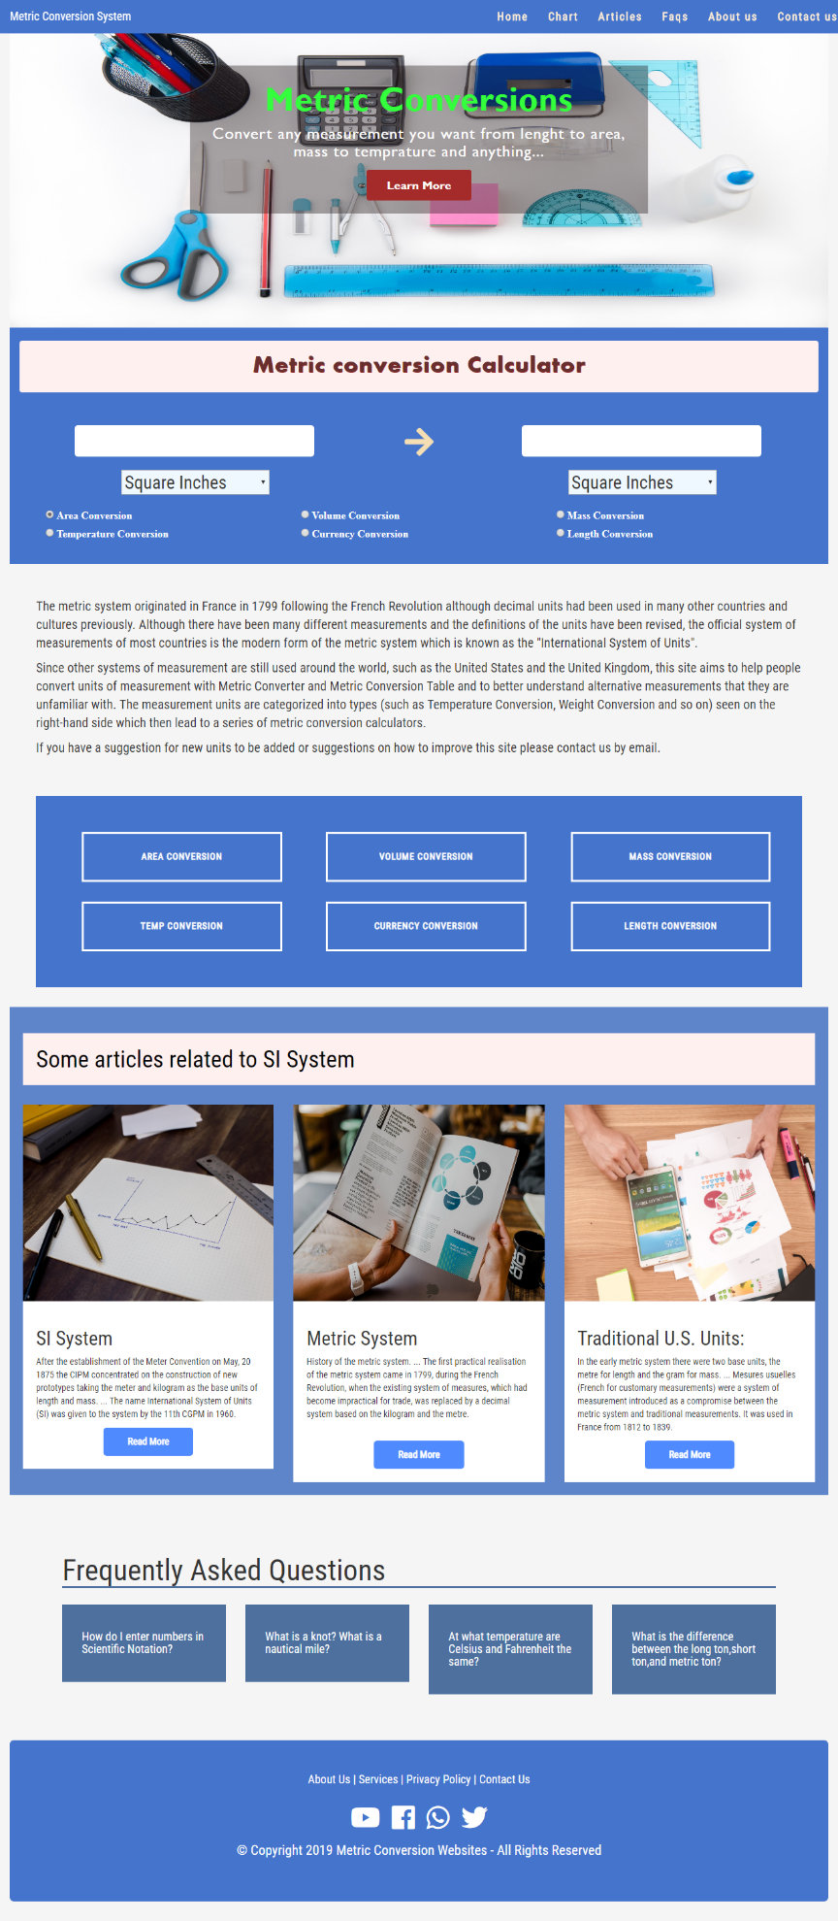The Home Page of Metric Conversion Website is following:

The main calcultor is presented in home page which contains almost all metric conversions and every metric conversion can be calculated through it.

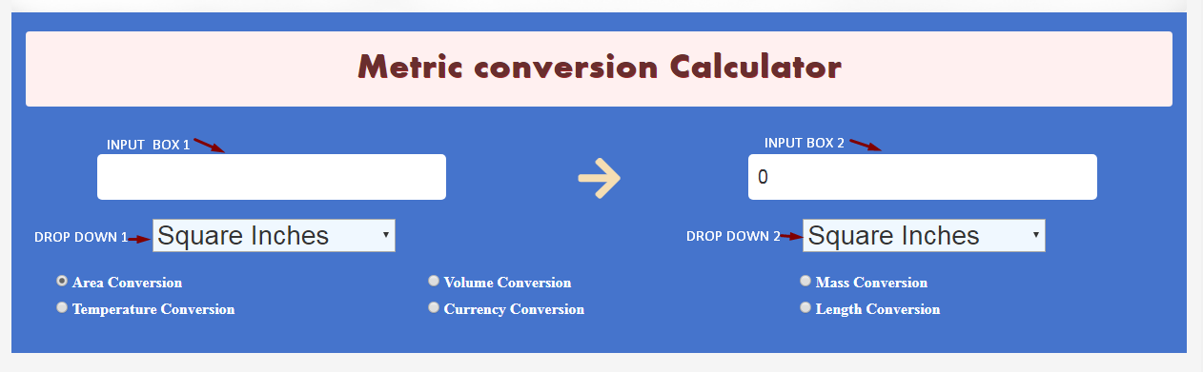By clicking on a radio button, the user will get selected conversion units in dropdown lists.

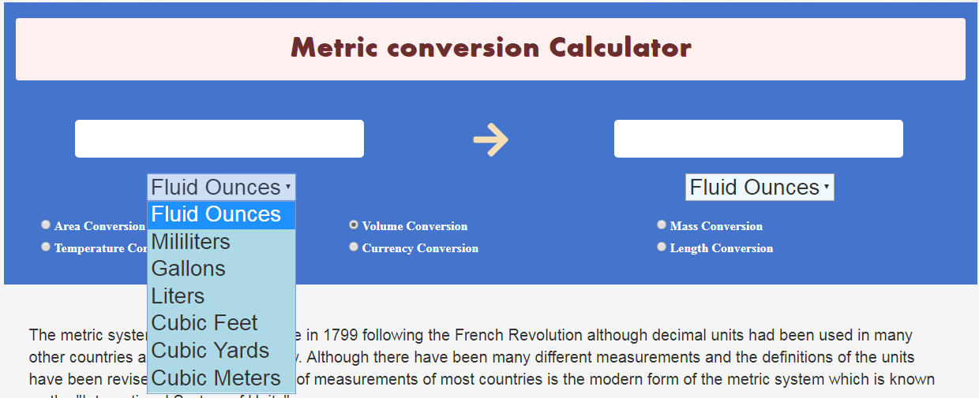After selecting a Conversion, the user can select the units to convert from dropdown 1 and select the unit to be convert from dropdown 2.

Then by typing in input box 1 the user will automatically get result in input box 2.

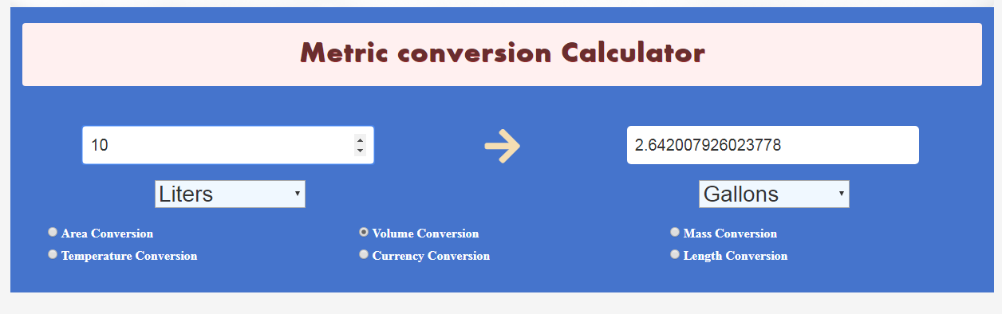

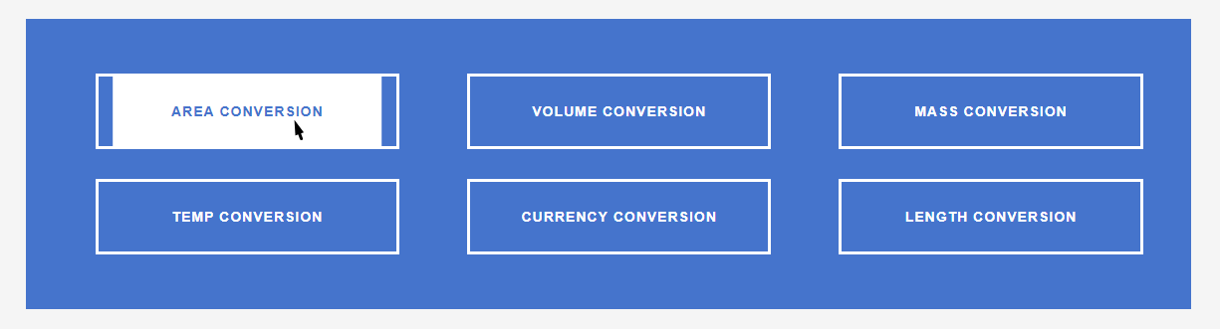It also contains separate calculators with short history and charts of specific conversions. The calculation can also be performed on these pages. These pages can be access by following buttons on home page.

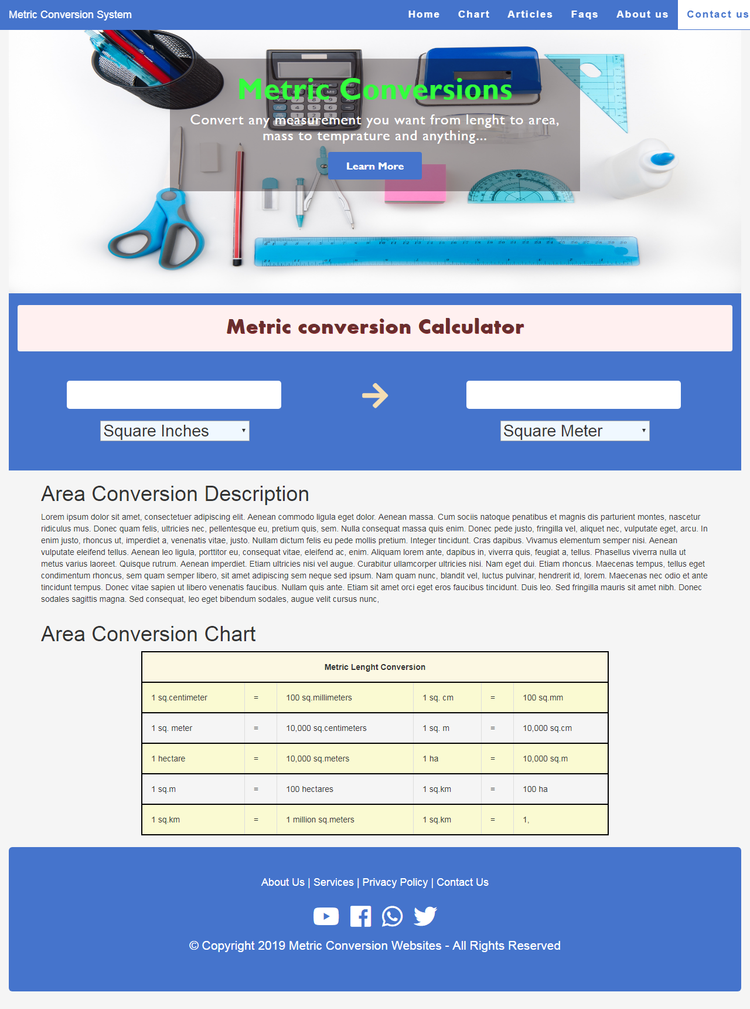

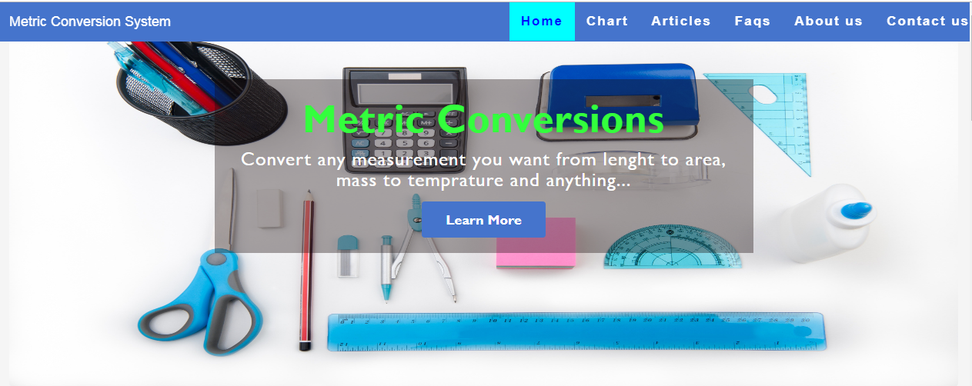The website also has separate pages for Charts, Articles and FAQ’s which can access through top Menu Bar.

The user can contact to site in case of any query or feedback through Contact us page on top Menu Bar.

**Thank You**